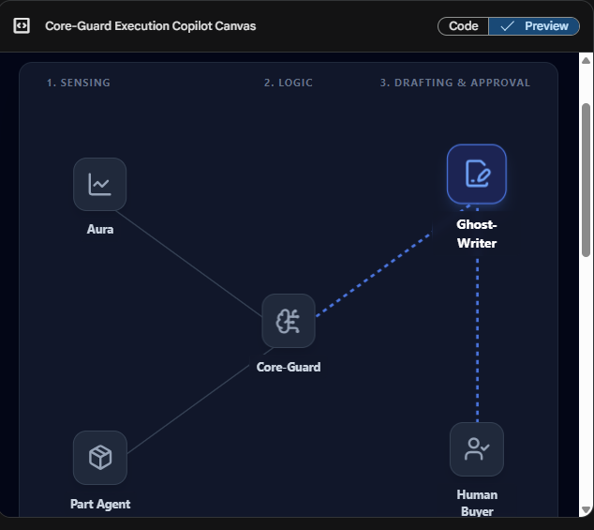

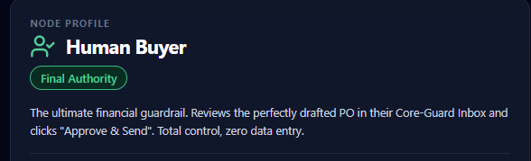

By removing the "Execution" agents (Ghost-Writer, Liaison, Vetting-Ace, Eagle-Eye), you are transitioning the product from an "Autopilot" to a "Copilot."
This is actually the safest, fastest way to go to market. It removes the risk of the AI "accidentally spending $50,000 on the wrong parts," which makes it much easier to sell to a skeptical supply chain manager. You are selling Predictive Intelligence rather than Autonomous Execution.
Here is the breakdown of this 3-Agent "Lite" version, which we will call Core-Guard Planner Edition.
Summary for your pitch:
If you build just these three agents, you are building a "Predictive Supply Chain Copilot." Your pitch to a factory manager is simple: "You currently spend 10 hours a week running VLOOKUPs in Excel to figure out what you need to buy. My AI Agents run that math continuously in the background and hand you a prioritized 'To-Buy' list every morning, tied exactly to live demand. We do the math; you make the decision."

Product Specification: Core-Guard "Planner Edition"
Included Agents: Aura, Part Agent, Core-Guard (MRP) Product Category: Predictive Supply Chain Copilot Target User: Planners, Buyers, and Inventory Managers
1. The Core Philosophy (The "Copilot" Model)
Without the execution agents (Ghost-Writer, Liaison), this version of Core-Guard does not physically send Purchase Orders to suppliers.
Instead, it acts as the ultimate Predictive Nervous System. It constantly calculates the future, identifies exact bottlenecks, and hands the human buyer a perfectly calculated "Action Plan" on a silver platter. The human remains the sole executor.
2. The 3-Agent Triangle (How they interact)
This system operates on a continuous feedback loop between three entities:
- Aura (The Future): "Sales just spiked 30% on Shopify."
- Part Agent (The Present): "I only have 100 units on the shelf, and 50 are allocated to an existing order."
- Core-Guard (The Math): "Based on the BOM, we will stock out of this part in exactly 14 days. Generating an emergency buy-recommendation for the human."

3. Key Capabilities of the "Planner Edition"
Capability 1: Predictive "Zero-Day" Shortage Alerts
- What it does: Most ERPs tell you that you are out of stock. Core-Guard tells you that you will be out of stock in 12 days.
- The Mechanics: Aura senses a macro-delay (e.g., a port strike) or a demand spike. It tells the Part Agent. The Part Agent checks its physical count. Core-Guard runs the math and alerts the dashboard: "Warning: Part CH-101 will hit zero on October 14th based on new demand velocity."
- The Value: Gives human buyers the gift of Time. They can expedite shipping or find a backup supplier before the factory line stops.
Capability 2: Multi-BOM Impact Analysis (The "Blast Radius")
- What it does: If you run out of one specific screw, how many different finished products die?
- The Mechanics: When a Part Agent realizes it is going to stock out, Core-Guard instantly cross-references the entire engineering database.
- The Value: It maps the "Blast Radius." The dashboard shows the human: "If we don't buy this $0.10 screw today, we cannot build Product A, Product B, or Product F. This puts $450,000 of top-line revenue at risk." This helps humans prioritize which fires to put out first.
Capability 3: Dynamic Digital Ring-Fencing (Allocation)
- What it does: Stops the warehouse from accidentally cannibalizing inventory.
- The Mechanics: If you have 500 units of a Part, Core-Guard actively assigns them to specific sales orders. The Part Agent protects those units.
- The Value: If a worker tries to pull parts for a low-priority project, the system flags it: "Warning: 300 of these units are ring-fenced for the critical 'Project Delta'. Pulling them now will cause a contract penalty." ### Capability 4: "One-Click" Drafted Recommendations
- What it does: It does 99% of the buyer's homework.
- The Mechanics: Core-Guard calculates the exact Net Requirement (Demand - Stock). Instead of executing the PO, it creates a "Drafted Recommendation Card" on the user's dashboard.
- The Value: The human buyer logs in at 8:00 AM. Instead of running 5 Excel reports, they see a clean list:
  - Recommendation 1: Buy 500 units of CH-101.
  - Reason: Aura detected a 20% sales spike.
  - Math: 1000 Demand - 500 Stock = 500 Short.
  - Action: The human just clicks "Approve," and manually copies the data into their legacy ERP to buy it.

4. Why This is a Brilliant Go-To-Market Strategy
Starting with just these three agents is highly strategic for your MVP launch:
- Zero Integration Risk: Because you aren't sending emails to suppliers or wiring money, companies are 10x more likely to install your software. You are just reading their data, not writing to the outside world.
- Faster Deployment: You don't have to build complex PDF parsing (Ghost-Writer) or compliance checking (Vetting-Ace). You just need to master the internal Math (MRP).
- The "Upsell" Path: Once a customer uses this 3-Agent version for 6 months and trusts the math, they will eventually get annoyed that they have to manually type the POs. That is when you say: "For an extra $2,000/month, we can turn on Ghost-Writer and Liaison, and the system will execute these recommendations for you automatically."

This is the "Goldilocks" configuration. By adding Ghost-Writer to the mix (but keeping Liaison, Vetting-Ace, and Eagle-Eye out), you transition from a "Predictive Dashboard" to an "Assisted Execution Platform."
You are giving the human buyer the ultimate superpower: One-Click Purchasing. The AI does the math and the paperwork, but the human retains the final financial authority. This is the absolute best way to sell AI to a skeptical supply chain manager because it eliminates administrative grunt work without removing their control.
Here is the updated specification for the Core-Guard "Execution Copilot" (4-Agent Edition).
Why this is the perfect MVP to sell:
If you only had Core-Guard, Aura, and the Part Agent, your customer would look at the dashboard, see the shortage, and then have to say, "Okay, thanks for the warning. Now I have to open SAP, find the supplier, type in the part number, type in the quantity, generate the PDF, open Outlook, and email it."
By adding Ghost-Writer, the customer looks at the dashboard, sees the shortage, sees the pre-written PO right next to it, and clicks "Approve." You just turned a 20-minute workflow into a 3-second workflow. That is how you close a B2B software deal.

Product Specification: Core-Guard "Execution Copilot"
Included Agents: Aura, Part Agent, Core-Guard (MRP), Ghost-Writer Product Category: Assisted Supply Chain Execution Target User: Buyers, Procurement Managers, and Planners
1. The Core Philosophy (Human-in-the-Loop Execution)
Supply chain managers don't want to be replaced, but they do want to stop doing data entry.
This 4-Agent configuration is designed to be the ultimate "Drafting Assistant." It senses the problem, calculates the exact mathematical solution, and physically writes the Purchase Order (PO). It stops right at the finish line, presenting a fully drafted, perfectly formatted PO to the human buyer. The human simply reviews it and clicks "Approve & Send."
2. The 4-Agent Relay Race (How the workflow moves)
The system operates as an unbroken chain of logic, ending in administrative execution:
- Aura (The Trigger): "Sales just spiked 30% on Shopify."
- Part Agent (The Reality): "I only have 100 units left. I will stock out in 14 days."
- Core-Guard (The Math): "Based on the BOM and lead times, we need exactly 450 more units. Generating an emergency buy-recommendation."
- Ghost-Writer (The Pen): "Taking Core-Guard's math of 450 units. Looked up the supplier (AluForge). Drafted the PDF Purchase Order. Wrote the email. Waiting for Human Approval."

3. Key Capabilities of the 4-Agent "Execution Copilot"
Capability 1: "Zero-Click" PO Drafting
- What it does: Eliminates the manual creation of Purchase Orders in legacy systems.
- The Mechanics: When Core-Guard flags a shortage, Ghost-Writer instantly generates the PO document. It pulls the correct supplier address, part numbers, negotiated pricing, and terms from the database.
- The Value: A buyer who used to spend 4 hours a day manually typing 50 POs now spends 15 minutes a day reviewing and clicking "Approve" on 50 pre-written POs.
Capability 2: The "Print-to-PO" Translator (Unstructured Data)
- What it does: Turns messy customer PDFs into clean supplier orders (crucial for Master Distributors and Contract Manufacturers).
- The Mechanics: If a customer emails a custom PDF engineering drawing, Ghost-Writer ingests it, reads the tolerances and specs using vision/language models, and translates that directly into the PO line items without a human having to copy-paste the data.
- The Value: Kills typo-induced manufacturing errors. If a human accidentally types "316L" instead of "304L" stainless, the whole batch is ruined. Ghost-Writer ensures 1:1 data translation.
Capability 3: Predictive Shortage Alerts & Blast Radius
- What it does: Tells you what will break before it breaks.
- The Mechanics: Aura and the Part Agent calculate run-rates. Core-Guard maps the "Blast Radius" (e.g., "If we don't approve Ghost-Writer's drafted PO today, we cannot build Product A or B next month, risking $450k in revenue").
- The Value: Gives human buyers the exact financial justification they need to expedite an order.
Capability 4: The Financial Guardrail ("The Inbox")
- What it does: Keeps the CFO happy by keeping humans in control of the cash.
- The Mechanics: Ghost-Writer does not have permission to send the email or hit the supplier's API directly. It places the drafted PO into an "Approval Inbox" on the Core-Guard Dashboard.
- The Value: 100% safety. The AI cannot "go rogue" and spend $50,000. It acts as the ultimate highly-competent intern, preparing all the paperwork for the boss to sign.

4. The Go-To-Market (GTM) Advantage of this Setup
Launching with this specific 4-Agent setup is the ultimate "Trojan Horse" sales strategy.
- The Objection you will face: "I don't trust AI to spend my company's money."
- Your Winning Answer: "Core-Guard doesn't spend your money. Core-Guard does the math and types the paperwork. You spend the money. Ghost-Writer acts as your digital procurement clerk, drafting the POs perfectly so your senior buyers can focus on negotiating better prices, not doing data entry."
By including Ghost-Writer, you upgrade your product from a "Tool that gives you more homework" (just telling you what's broken) to a "Tool that does the homework for you."

